**Software Engineering Module 1 SDLC**

1. **What is Software ? What is Software Engineering ?**

Software is a set of instructions or set of programs. Software tells the computer what to do and how to do.

Software engineering is a technique through which we can develop or create software for computer systems or any other electronic devices. Software Engineering is a process in which user needs are analysed and software is designed based on their need.

1. **Explain types of software**

There are three types of software. System Software, Application Software and Utility Software

1. **System software** – System Software is a software designed to provide a platform to other software. System software controls and manage the operations of computer hardware. Ex. Windows, android, linux
2. **Application Software** – The software helps you to do a specific type of work is called application software. Ex. Ms word, excel etc.
3. **Utility Software** – Helps to manage, maintain and control computer resources. Like antivirus, backup software, disk tools etc.
4. **What is SDLC? Explain each phase of SDLC**

SDLC stands for software development life cycle. It describes the sequence of phases or steps to develop any software from customer requirement to actual product launch in market. SDLC defines some processes which are followed to develop a high quality software.

Phases of SDLC are as follows:-

1. Planning – Business Analyst collect request from the customer/client as per the client business needs and provides the development team.
2. Analysis – Once the requirement gathering is done next step is “to define and document the product requirements and get them approved from the customer.”

This is done through software requirement specification (SRS). Key people involve in this phase are Project Manager, Business Analyst and senior members.

1. Design – In this phase designing of software is done. How product look like after development is made. It describes how each and every feature in the product should work and how every component should work. It gives architecture of the software product.
2. Implementation – In this phase building of the software is started and started writing of the code. Responsiveness is also done in this phase.
3. Testing & Integration – When all component of the software is ready, all component are integrated and final product is made and sent to testing department. Testing department check weather software is error free or not.
4. Maintenance – once the customer starts using developed software then the actual problems will come and need to be solved time to time. Old features will be removed and new features will be added.
5. **What is Flow chart? create a flow chart to make addition of two numbers.**

Flow chart represents flow of program. How program will start working.

Components of flow charts are :-

Decision

Input/Output

Process

Arrow

Program of Adding two numbers:-

Display Sum

Sum = a+b

Input Numbers: a, b

1. **What is DFD? Create a DFD diagram on Flipkart**

DFD stands for Data Flow Diagram. It is also known as Bubble chart. Through which we can represent flow of data graphically in an information system. By using DFD we can easily understand the overall functionality of system because diagram represents incoming data flow, outgoing data flow and stored data in a graphical format.

It describes how data is processed in a system in terms of input and output.

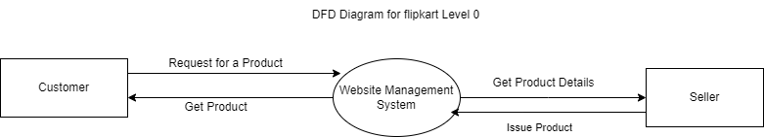

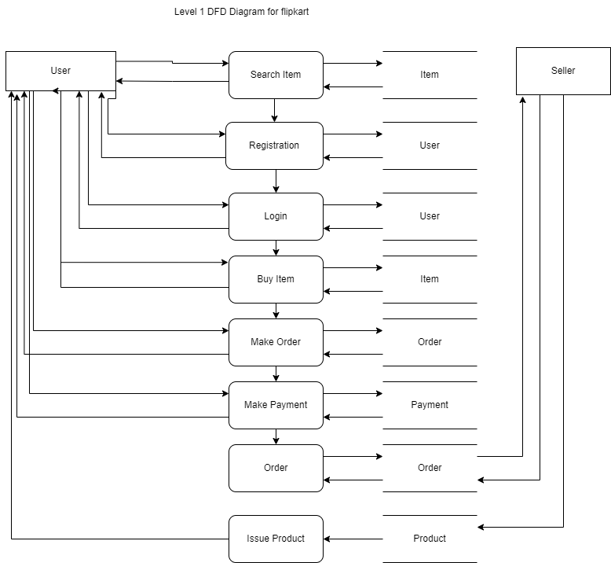

1. **What is Use case Diagram? Create a use-case on bill payment on paytm.**

A use case diagram is a graphical depiction of a user's possible interactions with a system. A use case diagram shows various use cases and different types of users the system has and will often be accompanied by other types of diagrams as well. The use cases are represented by either circles or ellipses

